**TASK 1**

**Objective:**

Write a C++ that maintain record of students. Student contains following details:

* ID
* Name
* Department
* Email
* Phone no

Create a structure of student. Ask user to enter record for two students. Store those details in variables of students type. Print those records on screen.

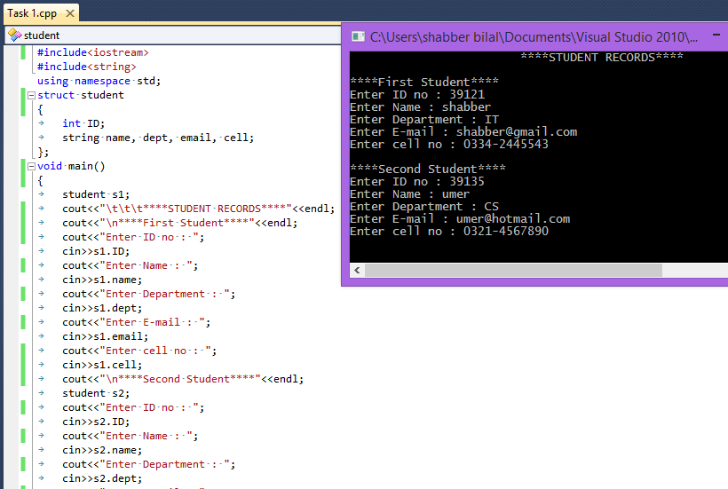

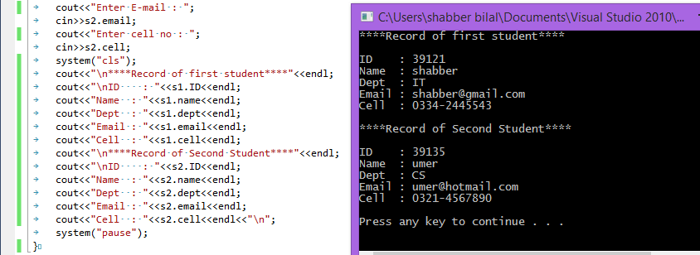

**TASK 2**

**Objective:**

Create a structure num.Member of structure aretwo integers num1 and num2.Assign values 5 and 6 respectively.Access the member through pointers and print the values.

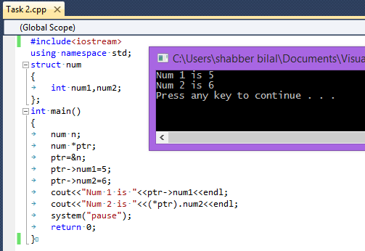

**TASK 3**

**Objective:**

Write a C++ program that compute Net Salary of Employee. Program contains two user defined functions empSalary() and display().

* Create a structure of Employee that contains following data members: EmployeeNumber, Name, BasicSalary, HouseAllowence, MedicalAllowence,Tax, GrossPay and NetSalary
* empSalary() compute salary with given criteria
  + HouseAllowence = 10% of BasicSalary
  + Medical Allowence = 5% of Basic Salary
  + Tax = 4 % of Basic Salary
  + GrossSalary = Basic+HouseAllowence+MedicalAllowence
  + NetSalary = GrossSalary – Tax
* display() for displaying details of Empolyee

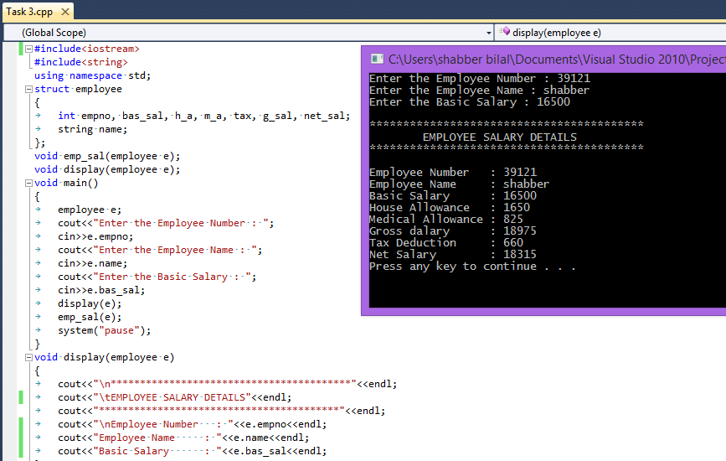

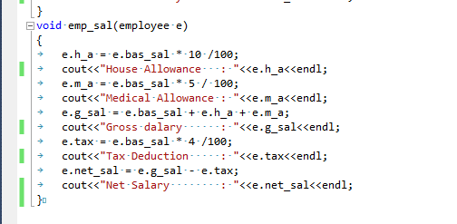

**TASK 4**

**Objective:**

Write a C++ program for billing system of MovInPeak restaurant. The program should perform following tasks:

* Show menu to customer for orders.
* Allow the customer to select more than one item from the menu.
* Calculate and print the bill.

Assume that the restaurant offers the following items (the price of each item is shown to the right of the item):

* Omlet $1.45
* French Omlet $2.45
* Muffin $0.99
* French Toast $1.99
* Fruit Basket $2.49
* Cereal $0.69
* Coffee $0.75
* Tea $0.50

Notes:

Define a struct MovinPeakMenu that contains following data members.

* menuItem [ ] of type string
* menuPrice [ ] of type double

Your program must contain following functions:

* Function getData: This function store the food items into the array menuList.
* Function showMenu: This function shows the different items offered by the restaurant and tells the user how to select the items.
* Function printCheck: This function calculates and prints the check.

(Note that the billing amount should include a 5% tax.)